
Data Security Envisioning Workshop
06-Module Delivery Guide-On premises
v8.5 - January 2026

Contents
Disclaimer 3
Version history 4
We look forward to your feedback! 4
1 Introduction 5
1.1 Objectives 5
1.2 Delivery guidance 5
1.3 Scoping 6
1.4 Estimated partner effort 6
1.5 Infrastructure requirements 6
1.6 Tools and services used 6
2 Activity details 8
2.1 Step 1 - Kick-off meeting 8
2.2 Step 2 - Acquire and assign licenses 8
2.3 Step 3 - Setup and configuration 9
2.3.1 Purview Information Protection scanner pre-requisites 11
2.3.2 Configure the Purview Information Protection scanner service account 12
2.3.3 Create a Sensitivity Label 14
2.3.4 Create and publish a Label Policy 17
2.3.5 Install the Purview Information Protection scanner configuration database 19
2.3.6 Install the Purview Information Protection client 20
2.3.7 Configure the Purview Information Protection scanner in the Microsoft Purview portal 21
2.3.8 Install the Purview Information Protection scanner 23
2.3.9 Acquire a Microsoft Entra token for the scanner 24
2.3.10 Run on-premises Automated Discovery 28
2.4 Step 4 - Analyze the findings 31
2.4.1 Prepare for analysis using Activity Explorer 31
2.4.2 Analyzing Activity Explorer results 34
2.4.3 Analyzing discovery findings scanner log files (Optional) 37
2.5 Step 6 - Decommission 39

Disclaimer
The Data Security Envisioning Workshop provides a summary of an organization’s data protection and compliance stature and recommendations to improve data protection and compliance.
The information, results, and scoring provided through the Data Security Envisioning Workshop are recommendations and provided for general informational purposes only. They do not constitute legal advice, certifications, or guarantees regarding regulatory compliance; it is up to each organization to evaluate the effectiveness of these recommendations in their respective regulatory environment prior to implementation. Organizations should consult with their own legal professionals to determine how standards or regulations apply to their organization and how to best ensure compliance.
We hope the Data Security Envisioning Workshop helps identify technologies and additional steps that organizations can implement to simplify their compliance efforts.
MICROSOFT MAKES NO WARRANTIES, EXPRESS, IMPLIED, OR STATUTORY, AS TO THE INFORMATION IN THIS Data Security Envisioning Workshop. Microsoft disclaims any conditions, express or implied, or other terms that use of the Microsoft products or services will ensure the organization’s compliance with regulations or standards. This Data Security Envisioning Workshop toolkit is provided “as-is.” Information and recommendations expressed in the Data Security Envisioning Workshop toolkit may change without notice.
The Data Security Envisioning Workshop toolkit does not provide the user with any legal rights to any intellectual property in any Microsoft product or service. Use of the tool is for internal, reference purposes only; however, Microsoft partners may distribute the Data Security Envisioning Workshop toolkit to their customers for such customers’ internal, reference purposes only. Any distribution of the Data Security Envisioning Workshop toolkit by a Microsoft partner to its customers must include terms consistent with those set forth in this disclaimer.
© 2026 Microsoft. All rights reserved.

Version history
Version | Author | Changes | Date
3.0 | François van Hemert | First published modular release | January 2021
3.1 | François van Hemert | Updated version number to align with kit, no changes. | February 2021
3.1.1 | François van Hemert | Updates to align with new functionality, included AIP Scanner preview (AIP Analytics audit logs to Activity Explorer). | April 2021
4.0 | François van Hemert | Workshop split, update to align with new narrative, rebranding, updates to guidance and organized around data repositories. | June 2021
4.1 | François van Hemert | Update illustration for Compliance Manager Premium Assessments. | October 2021
4.2 | François van Hemert | Purview branding update, step-by-step guidance update to align with changes M365. | July 2022
4.2.2 | François van Hemert | Update to align with current product features and functionality (evergreen). | January 2023
6.0 | François van Hemert | Workshop merge, align with FY24 solution play, focus on Data Security. | August 2023
6.5 | François van Hemert | Update install steps to align with Purview configuration | July 2024
6.6 | François van Hemert | Update to align with the new Microsoft Purview Portal | October 2024
7.0 | François van Hemert | Updated for additional module on Generative AI | January 2025
7.1 | François van Hemert | Version number update, no further changes | May 2025
8.0 | François van Hemert | Update to align with current product features and functionality (evergreen), update name, update branding. | July 2025
8.5 | François van Hemert | Update to align with current product features and functionality (evergreen) | January 2026


We look forward to your feedback!
Thank you for your continued trust and partnership. The resources within this toolkit will be iteratively improved upon based on product releases as well as direct feedback from delivered engagements. We encourage you to provide feedback to help us improve our products and toolkits.
Please share your feedback and questions via our Engagement feedback form that can be found at: https://aka.ms/SCIEngagementsFeedback.

Introduction
This document contains delivery guidance for the optional On-premises discovery activity that will extend the Automated Discovery Process to also scan on-premises data repositories such as file shares and SharePoint libraries for data that may impose data security risks to the organization.
The outcome and findings of this activity will be merged into the overall findings and recommendations that will be presented at the end of the Data Security Envisioning Workshop.

Objectives
The objectives for this activity are:
- Discover data security risks in on-premises data repositories.
Gain visibility into existing, and sometimes hidden, privacy and regulatory risks that might exist in the customer’s organizational data stored in the on-premises data repositories such as file shares and SharePoint libraries.
- Understand how to mitigate the identified data security risks.
Help customers to better understand, prioritize, and mitigate these privacy and regulatory risks across the on-premises data repositories.
- Provide recommendations and define next steps.
Recommendations and next steps based on the findings from this activity will be rolled up into the overall Data Security Envisioning Workshop close-out presentation.

Delivery guidance
This document is an integral part of the overall delivery guidance for the Data Security Envisioning Workshop. When delivering the Data Security Check, follow the guidance provided in the <00-Master Delivery Guide> and when instructed, engage in the supplemental activities outlined in this guide.
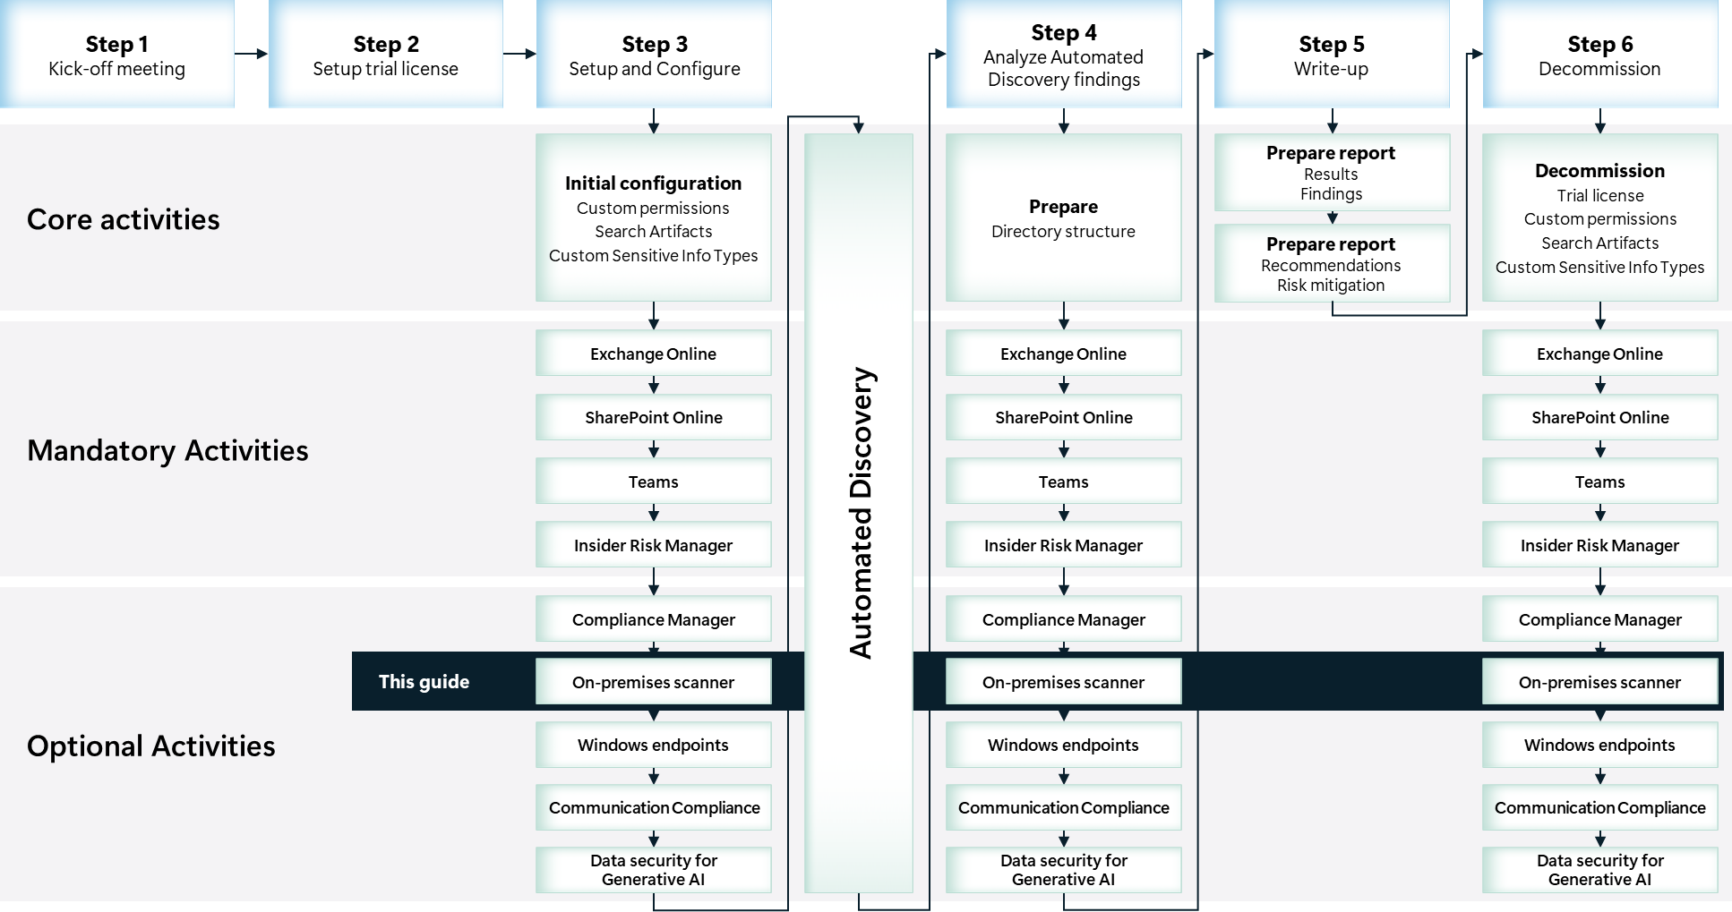

Scoping

In scope
The scope for this activity includes:
- Install and configure Microsoft Purview Information Protection scanner.
- Gain visibility into hidden data security risks in a subset of on-premises data repositories in use by the customer.

Estimated partner effort
The table below provides a high-level estimate of the additional partner effort for the activities described in this guide. The numbers provided are to be considered indicative and can change as a result of customization of the delivery schedule and the individual activities.
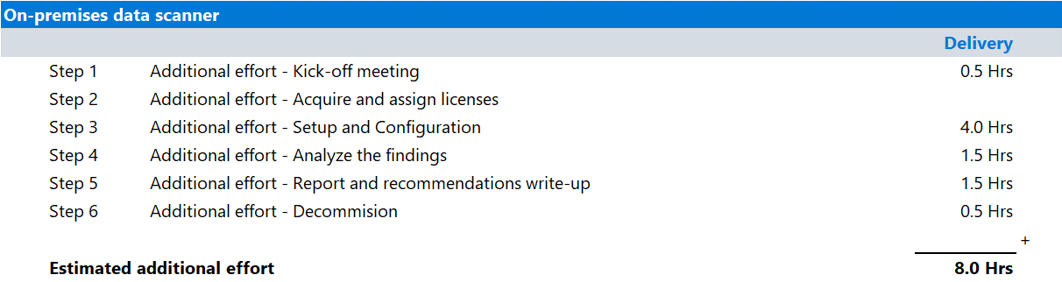

Infrastructure requirements
Before installing the Purview Information Protection scanner, make sure that your system complies with basic Azure Information Protection requirements, refer to Azure Information Protection requirements for an up-to-date list of requirements.
Additionally, specific requirements apply to the scanner, for further details refer to: Get started with the information protection scanner.

Tools and services used
The Data Security Check Automated Discovery process leverages Purview Information Protection scanner to discover and report on privacy and regulatory risks.

Overview
Microsoft Purview is a cloud-based solution that helps an organization classify and optionally protect its documents and emails by applying labels. Labels can be applied automatically by administrators who define rules and conditions, manually by users, or a combination of both where users are given recommendations but can choose for alternatives.
Purview Information Protection scanner extends the Data Security Check to on-premises data repositories such as file shares and SharePoint Server libraries.

Product information
For more information about the Microsoft Purview Information Protection scanner, refer to:
- Learn about the information protection scanner

Functionality used by the Data Security Check
The Data Security Check will leverage Purview Information Protection scanner for the discovery of privacy and regulatory risks in:
- On-premises data repositories such as file shares and SharePoint libraries.

Activity details

Step 1 - Kick-off meeting

Guidance
Follow the guidance for the Kick-off meeting provided in <00-Master Delivery Guide> and add an additional section to the meeting(s) to discuss:
- On-premises Automated Discovery by using the Purview Information Protection scanner
- The number and locations of on-premises data sources to be included in the Auto Discovery process.
The <40-Pre-engagement and Kickoff deck> contains optional slides with speaker notes that can be used to facilitate the discussion.

Supporting materials
- <40-Pre-engagement and Kickoff deck>
Note
The <40-Pre-engagement and Kickoff deck> is used during the Pre-engagement meeting and the Kick-off meeting. Instructions on how to update the slides are included as hidden slides in the deck.

Pre-requisites
The activities and guidance described in this step complement Step 1 - Kick-off meeting as described in the <00-Master Delivery Guide>. The activities should be merged and delivered as one.

Next step
- Return to the <00-Master Delivery Guide> and continue the guidance provided in Step 1 - Kick-off meeting.

Step 2 - Acquire and assign licenses
The required product licenses for this activity are included in the overall Data Security Check trial license that was deployed in Step 2 - Acquire and assign licenses described in <00-Master Delivery Guide>. No additional (trial) licenses are required.

Next step
- Return to the <00-Master Delivery Guide> and continue the guidance provided in Step 2 - Acquire and assign licenses.

Step 3 - Setup and configuration

Guidance
This section describes the steps required to install, configure, and run the Purview Information Protection scanner as part of the Data Security Check Automated Discovery for on-premises data repositories.
The Purview Information Protection scanner extends Automated Discovery for the Data Security Check to on-premises data sources such as:
- UNC paths for network shares that use the Server Message Block (SMB) protocol.
- Document libraries and folders for SharePoint Server (supported versions: 2019 through 2013).
The Purview Information Protection scanner can inspect all files that can be indexed by the Windows operating system and relies on the use of IFilters that are installed on the computer the Purview Information Protection scanner is installed on.
The search artifacts defined during the mandatory activities that are described in <00-Master Delivery Guide> are used to scan data for data security risks in the on-premises data stores. These search artifacts will be retrieved from Microsoft 365 through the Unified Labeling Client that will be installed on the computer running the Purview Information Protection scanner. Configuration and operational data for the Purview Information Protection scanner will be stored in a SQL database that can be installed on the Purview Information Protection scanner computer or on a dedicated machine. The illustration below depicts a high-level overview of the envisioned installation.
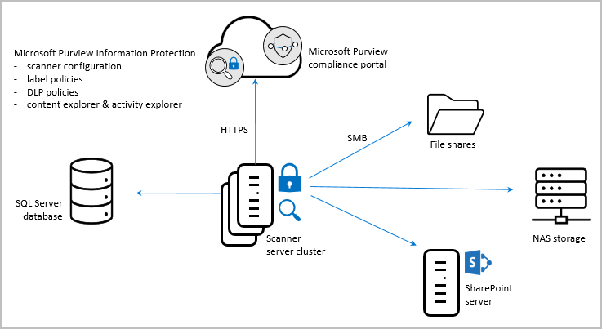
Note
Depending on the data volume in the customer’s environment, multiple instances of the Purview Information Protection scanner and a separate, high-performance SQL Database server may be required. Refer to Optimize scanner performance for more details.

Purview Information Protection scanner supports running in multiple operating modes:
- Discover only mode. The Purview Information Protection scanner scans the data sources and identifies files that contain (the predefined) Sensitive Info Types.
- Enforce mode. The Purview Information Protection scanner scans the data sources and files that contain the predefined Sensitive Info Types will automatically be labelled. The applied labels will apply classification, and optionally, apply or remove protection.
 Important
The Purview Information Protection scanner will be configured to run in Discover only mode and will not apply labels or in any way modify, move, or delete existing data. All data will remain unchanged.
The instructions provided in the following paragraphs assume a relatively simple single-scanner, single-region deployment. In larger production environments with multiple regions, it is recommended that policies are created per-region with an associated scanner deployed close to each region’s resources that need to be scanned. As an example, an organization may be well served by a scanner in Europe and another in the Americas, or if a large number of resources are located in one region, by deploying multiple scanners in that region and then dividing the resources to be scanned between the individual scanner deployments.
Note
The deployment of multiple Purview Information Protection scanner instances is considered out of scope for this engagement.

An operational Purview Information Protection scanner will generate a log file in CSV format after every scan. This log file will be saved to a local directory on the scanner server and contains information about the data that was scanned and sensitive information that was detected.
The logfile data can be accessed directly from the local scanner server or through the Microsoft Purview compliance portal audit logs or the Activity Explorer.
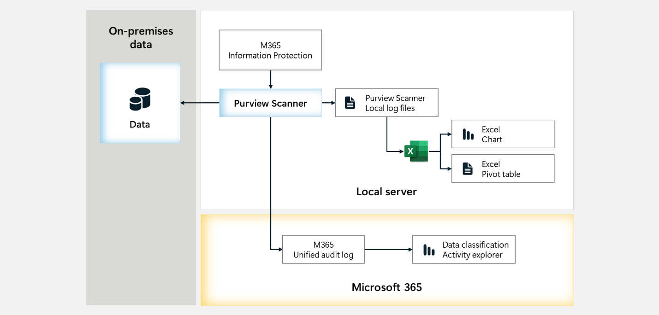

Background reading
For more information refer to:
- Learn about the information protection scanner
- Get started with activity explorer
- Search the audit log
- Labeling activities that are available in Activity explorer

Pre-requisites
Prior to starting the activities in this step, the following mandatory Data Security Check activities as described in <00-Master Delivery Guide> should be completed:
- Step 1 - Kick-off meeting
- Step 2 - Acquire and assign licenses
- Step 3 - Setup and configuration

 Important
Purview Information Protection scanner relies on Sensitive Info Types to identify privacy and regulatory risks. Before starting this activity, the instructions outlined in Step 3 - Setup and configuration in the 00-Master Delivery Guide should be completed successfully. (i.e., all customer specific sensitive information types configured and available).

Purview Information Protection scanner pre-requisites

Guidance
In order to successfully deploy Purview Information Protection scanner, several pre-requisites must be in place prior to starting the deployment:
- Windows Server computer that will run the installed and available scanner service.
- Service account to run the scanner service.
- SQL Server to store the scanner configuration.
 Important
Before installing Purview Information Protection scanner, carefully read the detailed requirements that can be found at Get started with the information protection scanner.

Objectives
- Prepare for the installation of Purview Information Protection scanner and make sure all requirements are in place.
- Provide required hardware and software, user accounts, and other pre-requisites.
- Confirm the relevant identity and users and groups configurations for use of Information Protection.

Background Reading
- Get started with the information protection scanner
- Configure and install the information protection scanner

Configure the Purview Information Protection scanner service account

Guidance
A service account is required to run the Purview Information Protection scanner service on the on-premises Windows Server computer. Additionally, the service account will also be used to authenticate against Microsoft Entra ID and to download the Data Loss Prevention policy. The guidance provided in this section assumes the deployment model as depicted in the illustration below.
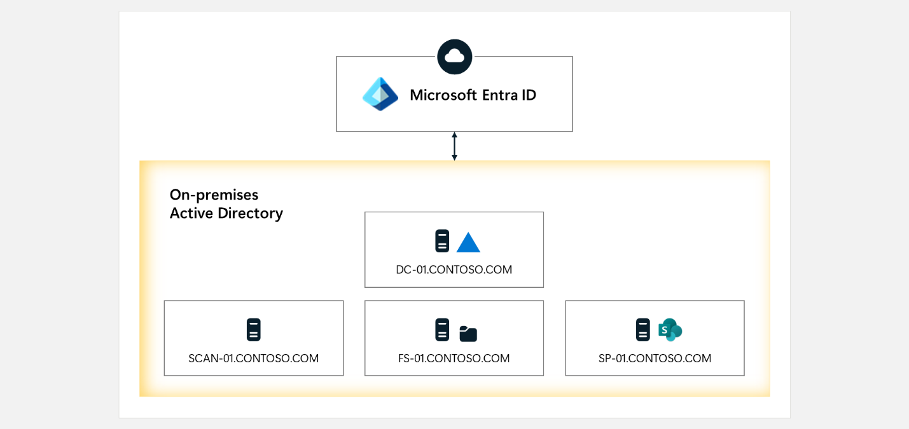
- The customer has deployed an on-premises Active Directory Domain (contoso.com).
- The on-premises Active Directory is synchronized to Microsoft Entra ID.
- The Windows Server running Purview Information Protection scanner is joined to the domain.
- The on-premises file servers and SharePoint Servers are joined to the domain.

This section provides guidance on creating the required service account.
 Important
The procedures to create accounts and assign required rights and permissions will vary from organization to organization. This section will therefore not describe step-by-step instructions but instead provides a high-level overview of actions and requirements.

Objective(s)
- Create a service account to be used by the Purview Information Protection scanner service.
- Assign required permissions and rights to the service account.

Pre-requisites
- No pre-requisites exist.

Background Reading
- Learn about the information protection scanner
- Deploying the scanner with alternative configurations
- Allow log on locally - security policy setting
- Configure security policy settings
- Get started with the information protection scanner
- Learn how user accounts and groups use the Azure Rights Management service

Instructions
- Create the Purview Information Protection scanner service account in the on-premises Active Directory. For the guidance described in this guide, SVC_Scanner will be used as the account name.
 Important
The service account should be created in an organizational unit (OU) that is synchronized with Azure Active Directory. Pay special attention to restrictive policies that might be assigned to the OU.

- Verify the account is synchronized to Azure Active Directory.
Note
The Purview Information Protection scanner service account must be an Active Directory account and synchronized to Azure AD. If organization policies prevent the account from synchronizing, refer to Deploying the scanner with alternative configurations section in the Get started with the information protection scanner document on Microsoft Docs.

- Assign log on locally rights to the service account on the server where the Purview Information Protection scanner will be installed.
  - Logon on to the server where the Purview Information Protection scanner will be installed with an account that has administrative privileges.
  - Open the Administrative Tools and open the Local Security Policy.
  - Expand Local Policies and click on User Rights Assignment.
  - In the right pane, right-click Allow log on locally and select properties.
  - Click on the Add User or Group… button to add the service account.

Note
The log on locally right is required for the installation and configuration of Purview Information Protection scanner. It must be granted to the service account but can be removed after installation. If granting this right even for a short period of time is not possible because of organizational policies, see the Deploying the scanner with alternative configurations section on Microsoft Docs.

- Assign log on as a service to the service account.
Note
No additional action is required, this right is automatically assigned during the installation of Purview Information Protection scanner.

- Grant Read permissions to file shares or local files the Purview Information Protection scanner will be scanning.
- Grant Read permissions to SharePoint document libraries the Purview Information Protection scanner will be scanning.
Note
The Purview Information Protection scanner service account only requires Read permissions for scanning the files for sensitive information. Modify, Write, and Full Control permissions are not required because the scanner will be running in discovery mode only. Refer to Service account requirements for more details and advanced configuration information.

Create a Sensitivity Label

Guidance
The Purview Information Protection scanner can operate in two operating modes:
- Scan for all Out-of-box Sensitive Info Types and Custom Sensitive Info Types available in the customer’s tenant. This mode does not require additional classification configuration but will have noticeable impact on scanner performance because the data will be scanned for all 315+ Out-of-box Sensitive Info Types plus all custom defined types.
- Scan for a subset of Sensitive Info Types. By creating an additional Sensitivity Label that is configured with only the Sensitive Info Types that are relevant to the customer (as defined during the Pre-engagement meeting or Kick-off meeting), the performance of the Purview Information Protection scanner will be less impacted and the scanning process can be completed in the allotted time.
The guidance in this section will provide the steps required to configure the scanner to only scan for Sensitive Info Types that are relevant to the customer (mode #2).
The Purview Information Protection scanner receives its configuration through the Purview Information Protection client by means of a Sensitivity Label. For the purpose of On-premises discovery a single Sensitivity Label will be created and published to the Purview Information Protection scanner. This Sensitivity Label will contain all previously identified Sensitive Info Types that were identified by you and the customer during the Pre-engagement meeting or Kick-off meeting

Objective(s)
- Create one Sensitivity Label that includes all customer relevant Sensitive Info Types.

Pre-requisites
- The configuration of Custom Sensitive Info Types as part of the mandatory activities that are described in <00-Master Delivery Guide> is completed.

Background reading
For more information refer to:
- Learn about Sensitivity labels
- Get started with Sensitivity labels
- Create and configure Sensitivity labels and their policies

Instructions
- Browse to the Microsoft Purview portal at https://purview.microsoft.com/ and log in with Tenant Admin credentials or a user account that is a member of your Data Security Check team and has been assigned the appropriate permissions.
- In the navigation bar on the left side, click on Solutions.
- In the Solutions navigator, click on Information Protection.
- On the Information Protection solution card, click on Sensitivity labels.
- On the Sensitivity labels page, click +Create a label.

Note
The guidance provided in this paragraph is built for organizations that have not yet migrated to the Modern Label Scheme. To learn more about the process to migrate to the Modern Label Scheme and the impact this has on creating labels, refer to Migrate parent sensitivity labels to label groups

- On the Provide basic details for this label page enter DataSecurityCheck-AutoDiscoveryLabel as Name.
- Enter DataSecurityCheck-AutoDiscoveryLabel as Display name.
- Leave the Label priority unchanged.
- Provide a meaningful Description for users.
- Provide a meaningful Description for admins.
- Click Next.
- On the Define the scope for this label page, select Files & other data assets.
- Verify that all other options are de-selected.

Note
De-selecting might trigger the Impact to current settings popup. If the popup is shown, click Confirm to automatically remove the ‘Meetings’ scope.

- Click Next.
- On the Choose protection settings for the types of items you selected page, verify that Control access , Apply content marking and Protect Teams meetings and chats are de-selected.
- Click Next.
- On the Auto-labeling for files and emails page, set Auto-labeling for files and emails to On.
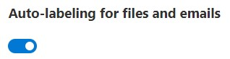
Note
Although Auto-labeling for Office apps is switched on, the Purview Information Protection scanner will not label or in any other way modify discovered content.

- Below Detect content that matches these condition click +Add condition, then click Content contains.
- Change the Group operator to Any of these.
- Below the Group name, click on Add and select Sensitive info types.
- On the Sensitive info types fly-out, select all Out-of-box Sensitive Info Types previously identified by you and your customer during the Pre-engagement meeting and/or Kick-off meeting
- On the Sensitive info types fly-out, select the Custom Sensitive Info Types built as part of the guidance in the <00-Master Delivery Guide>.
Note
The Custom Sensitive Info Types can be easily identified by searching for DataSecurityCheck-
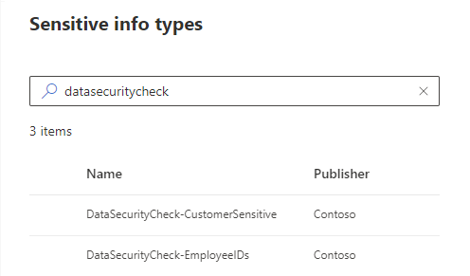

- Click Add.
- Below When content matches these conditions, verify Automatically apply the label is selected.
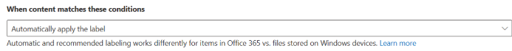
Note
Although “Automatically apply the label” is switched on, the Purview Information Protection scanner will not label or in any other way modify discovered content.

- Leave the text field below Display this message to users when the label is applied blank.
- Click Next.
- On the Define protection settings for groups and sites page, leave the default settings.
- Click Next.
- On the Review your settings and finish page, click Create label.
- On the Your label was created page, select Don’t create a policy yet.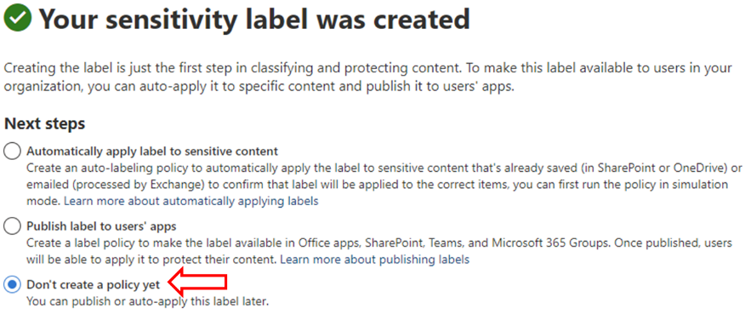
- Click Done.

Create and publish a Label Policy

Guidance
To instruct the Purview Information Protection scanner to use the Sensitivity Label created in the previous paragraph, a Label Policy needs to be created and assigned to the account that is running the Purview Information Protection scanner. This section will provide guidance on how to create a new Label Policy, assign it to the Purview Information Protection scanner service account, and publish it.

Objective(s)
- Create a Label Policy, assigned to the Purview Information Protection scanner service account and publish the policy.

Pre-requisites
- The configuration of the Sensitivity Label as described in the paragraph 2.3.3 is completed.

Background reading
For more information refer to:
- Learn about Sensitivity labels
- Get started with Sensitivity labels
- Create and configure Sensitivity labels and their policies

Instructions
- Browse to the Microsoft Purview portal at https://purview.microsoft.com/ and log in with Tenant Admin credentials or a user account that is a member of your Data Security Check team and has been assigned the appropriate permissions.
- In the navigation bar on the left side, click on Solutions.
- In the Solutions navigator, click on Information Protection.
- On the Information Protection solution card, click on Sensitivity labels.
- On the Sensitivity labels page, click on the label created in the previous paragraph, DataSecurityCheck-AutoDiscoveryLabel.
- On the DataSecurityCheck-AutoDiscoveryLabel fly-out, click on Publish label.
- On the Choose Sensitivity labels to publish, below Sensitivity labels to publish, verify the DataSecurityCheck-AutoDiscoveryLabel is listed.
- Click Next.
- On the Assign admin units page, click Next.
- On the Publish to users and groups page, click on Edit next to All users and groups.
- On the Scope for users and groups fly-out, select Specific users and groups.
- Click on +Include users and groups.
- On the Choose users and groups fly-out, search for, and select the Purview Information Protection scanner service account.
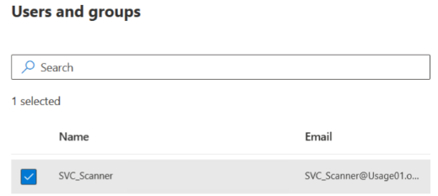
 Important
It is recommended to only assign the policy to the Purview Information Protection scanner service account; using the default <all users> setting may have an impact on Microsoft 365 apps because it will enable the built-in labeling capabilities for each end-user.

- Click Done.
- On the Scope for users and groups fly-out, click on Done.
- On the Publish to users and groups page, click Next.
- On the Policy settings page, enable Require users to apply a label to their emails and documents, leave all other options disabled.
- Click Next.
- On the Default settings for documents page, verify Default label is set to None.
- Click Next.
- On the Default settings for emails page, set Default label to None.
- Leave Require users to apply a label to their emails enabled (default setting).
- Leave Email inherits highest priority label from attachment disabled (default setting).
- Click Next.
- On the Default settings for meetings and calendar events page, set Default label to None.
- Leave Require users to apply a label to their meetings and calendar events disabled (default setting).
- Below Apply inheritance between Teams meeting and artifacts, set Inherit label from files shared to meetings to Do not inherit highest priority label from file.
- Click Next.
- On the Default settings for Fabric and Power BI content page, set Default label to None.
- Click Next.
- On the Name your policy page, enter DataSecurityCheck-AutoDiscoveryPolicy as Name and provide a meaningful description.
- Click Next.
- Click Submit.
- Click Done.

Install the Purview Information Protection scanner configuration database

Guidance
The Purview Information Protection scanner requires a SQL Server database to record information that it identifies for the data repositories that are scanned. This section discusses the steps to install Microsoft SQL Server Express on the Windows server the Purview Information Protection scanner instance is installed on.
 Important
To maximize the performance of the Purview Information Protection scanner, consider deploying the SQL Server database on a separate system. Refer to Optimizing scanner performance and Storage requirements and capacity planning for SQL Server for further guidance.

Objective(s)
- Install Microsoft SQL Server Express on the Purview Information Protection scanner server.

Pre-requisites
- No pre-requisites exist.

Background Reading
- Get started with the information protection scanner
- Deploying the scanner with alternative configurations
- Optimize scanner performance
- Storage requirements and capacity planning for SQL Server

Instructions
Note
This section will only provide generic guidance on how to install SQL Server. For detailed information, please refer to product guidance on Microsoft Docs.

- Download Microsoft SQL Server 2016 (or higher) Express from the Microsoft website.
- Install SQL Server by choosing the New SQL Server stand-alone installation or add features to an existing installation option.
 Important
If the account that is used to install SQL Server will also be used to install Purview Information Protection scanner, the automatically assigned SQL Sysadmin role will enable the Purview Information Protection scanner installation process to automatically create the scanner configuration database and grant the required db_owner role to the Purview Information Protection scanner service account. If the installation account cannot be granted the Sysadmin role or if organizational policies require databases to be created and configured manually, refer to the Deploying the Scanner with alternative configurations section for additional information. To avoid additional complexity, it is recommended to use the same account for both the installation of SQL Server and Purview Information Protection scanner. In this case the account must also be local administrator on the system where the Purview Information Protection scanner and SQL Server will be installed.

Install the Purview Information Protection client

Guidance
The Purview Information Protection scanner relies on functionality offered through the Purview Information Protection client. This section describes the steps required to install the Purview Information Protection client on the server that will run the Purview Information Protection scanner.

Objective(s)
- Install the Purview Information Protection client on the Purview Information Protection scanner server.

Pre-requisites
- All steps described in previous paragraphs have been completed successfully.

Background Reading
- Information protection client requirements
- Learn about the information protection scanner

Instructions
- Log on to the server that will run Purview Information Protection scanner with the previously created service account (SVC_Scanner).
- Download the latest version of the Microsoft Purview Information Protection client from Download Microsoft Azure Information Protection from Official Microsoft Download Center
- Open the downloaded executable to start the installation process.
- Select I acknowledge that the AIP add-in for Office will be uninstalled.
- Click I agree to accept the license terms and conditions.
- Wait for the installation to complete.
- Click Close.

Configure the Purview Information Protection scanner in the Microsoft Purview portal

Guidance
Before installing the Purview Information Protection scanner, a scanner cluster and a content scan job containing configuration settings and data repositories must be created. This section provides step-by-step instructions to define the profile based on the following guiding principles:
- The scanner will be configured to only search for all previously created Custom and Out-of-box Sensitive info types.
- The scanner will not apply labels to files or any other types of data.
- Existing labels applied to documents will be preserved and will not be modified, replaced, or removed.

Objective(s)
- Define the Purview Information Protection scanner configuration.

Pre-requisites
- The Label Policy described in section 2.3.4 Create and publish a Label Policy, is published.

Background reading
For more information refer to:
- Configure and install the information protection scanner
- Create a scanner cluster

Instructions
Create scanner cluster
- Browse to the Microsoft Purview portal at https://purview.microsoft.com/ and log in with Tenant Admin credentials or a user account that is a member of your Data Security Envisioning Workshop team and has been assigned the appropriate permissions.
- In the navigation bar on the left side, click on Settings.
- On the Settings card, below Solution settings, click on Information protection.
- On the Information Protection settings page, click on Information protection scanner.
- From the tabs on the Information Protection settings page, select Clusters.
- On the Clusters tab, click on + Add.
- On the New cluster fly-out, enter DataSecurityCheck-ScannerCluster as the name of the new cluster.
- Specify a meaningful description to identify the cluster.
- Click Save.
Create Content Scan Job
- From the tabs on the Information Protection settings page, select Content scan jobs.
- On the Content scan jobs tab, click on + Add.
- On the Edit content scan job fly-out, enter DataSecurityCheck-ContentScanJob as the name of the new Content scan job.
- Specify a meaningful description to identify the content scan job.
- Below Cluster, select the previously created DataSecurityCheck-ScannerCluster from the drop-down menu.
- Below Schedule, select Manual.
Note
For the initial configuration, the Purview Information Protection scanner will be configured to run on demand only. After successfully completing the first scan cycle, you can choose to run the scanner continuously to also include data that is added or modified throughout the discovery period. If this type of behavior is required, update the setting for the schedule to Always.

- Below Info types to be discovered, select Policy Only.
 Important
By configuring <Policy only>, the Purview Information Protection scanner will only scan the Sensitive Info Types defined in Sensitivity Label created in paragraph 2.3.2. Changing the setting to <All> will impact the duration of the scan and scanner performance.

- Below Treat recommended labeling as automatic, select Off.
Data Loss Prevention (DLP) Policy
- Below Enable DLP rules select Off.
Sensitivity labeling policy
- Below Enforce sensitivity labeling policy select Off.
Note
By selecting Off, the Purview Information Protection scanner will only identify files that contain sensitive data. Labels will not be applied, and data will not be modified or changed.

- Below Label files based on content select On.
- Below Default Label select None.
- Below Relabel files select Off.
Configure file settings.
- Below Preserve "Date modified", "Last modified" and "Modified by" select On.
- Below File type to scan select Exclude, leave the extensions as-is.
- Below Default owner select Scanner account.
- Below Set repository owner select Off.
Save the profile.
- Click Save to save the newly created Purview Information Protection scanner profile.
Add data stores to the Content scan job
- From the tabs on the Information protection settings page, select Content scan jobs.
- Click on the previously created DataSecurityCheck-ContentScanJob.
- From the tabs on the DataSecurityCheck-ContentScanJob fly-out, select Repositories.
- On the Repositories tab, click on + Add.
- Below Path, specify the path for the data repository.
Note
For a network share, use \\Server\Folder.
For a SharePoint library, use http://sharepoint.contoso.com/Shared%20Documents/Folder.
For a local path, use C:\Folder.
For a UNC path, use \\Server\Folder.

- Leave all other options set to Content scan job default.
- Click Save.
- Repeat the previous steps to add as many repositories as needed.
- Click on X to close the DataSecurityCheck-ContentScanJob page.

Install the Purview Information Protection scanner

Guidance
The Purview Information Protection scanner installation process is run from Windows PowerShell and creates the Purview Information Protection scanner Windows service. Additionally, the install process creates and configures a Purview Information Protection scanner database on the previously installed SQL Server. The service account specified to run the scanner will be granted the required rights to read from and write to the database that is automatically created.

Objective(s)
- Install the Purview Information Protection scanner.

Pre-requisites
- All steps described in previous paragraphs have been completed successfully.

Background Reading
- Configure and install the information protection scanner
- What is PowerShell?

Instructions
- Log on to the server that will run Purview Information Protection scanner with the previously created service account (SVC_Scanner).
- Open a Windows PowerShell session with the Run as an administrator option.
- Run the Install-Scanner cmdlet, specifying the SQL Server instance on which to create a database for the Purview Information Protection scanner and the name of the scanner profile that was created in the previous section:
Install-Scanner
-SqlServerInstance SCAN-01\SQLExpress
-Cluster "DataSecurityCheck-ScannerCluster"
- When prompted, provide the Active Directory credentials for the scanner service account.
Note
Use the following syntax: <domain\username>.
For example: contoso\svc_scanner.

- Verify the installation is completed successfully.
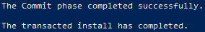
- Run services.msc and verify the Purview Information Protection scanner service is installed.
Note
The installed service is named Microsoft Purview Information Protection Scanner and is configured to run by using the scanner service account that you created..

Acquire a Microsoft Entra token for the scanner

Guidance
An Entra ID token is required to allow the Purview Information Protection scanner to authenticate to the Azure Information Protection service, enabling the scanner to run non-interactively. This section describes the steps required to obtain the required token.

Objective(s)
- Request an authentication token for use by the Purview Information Protection scanner.

Pre-requisites
- All steps described in previous paragraphs have been completed successfully.

Background Reading
- Get a Microsoft Entra token for the scanner
- Information Protection unified client: Create and configure Microsoft Entra applications for Set-Authentication

Instructions
- Browse to the Microsoft Azure portal at https://portal.azure.com and log in with Tenant Admin credentials or a user account that has been assigned the appropriate permissions.
- Navigate to the Microsoft Entra ID by typing Entra ID in the search box for resources, services, and docs and then select Microsoft Entra ID.
- On the left side menu below Manage, click App registrations.
- Click +New registration.
- On the Register an application page, below Name enter AIP-DelegatedUser.
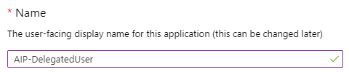
- Below Supported account types, select Accounts in this organizational directory only (Contoso only - Single tenant).
- Below Redirect URI (optional), select Web and enter https://localhost
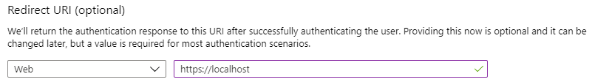
- Click Register.
- On the AIP-DelegatedUser page, copy the value for the Application (client) ID. This value will be used for the AppId parameter when executing the Set-AIPAuthentication cmdlet. Paste and save the value for later reference.
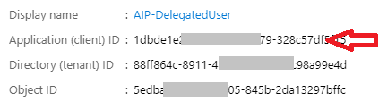
Application (client) ID | ...........……………………………………………………………………………………………

- On the left-side menu below Manage, click Certificates & Secrets.
- On the AIP-DelegatedUser | Certificates & secrets page, in the Client secrets section, click +New client secret.
- On the Add a client secret fly out, next to Description, enter Purview Information Protection unified labeling client.
- Next to Expires, select 365 days (12 Months).
- Click Add.
- On the AIP-DelegatedUser | Certificates & secrets page, copy the string below Value. Paste and save the value for later reference.
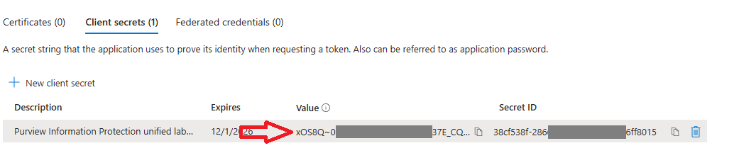
Client Secret Value | ...........……………………………………………………………………………………………

 Important
Verify you have copied and saved the client secret; it will not be possible to retrieve the value after leaving the AIP-DelegatedUser | Certificates & secrets page.

- On the left side menu below Manage, click API permissions.
- On the AIP-DelegatedUser | API Permissions page, click +Add a permission.
- On the Request API permissions page, on the Microsoft APIs tab, select Azure Rights Management Services.
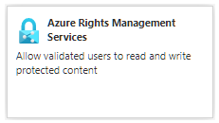
- Click on Application permissions.
- Below Select permissions, select Content.DelegatedReader and Content.DelegatedWriter
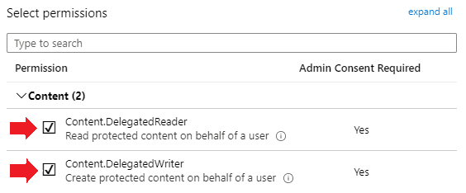
- Click Add permissions.
- On the AIP-DelegatedUser | API Permissions page, click +Add a permission.
- On the Request API permissions fly out select the APIs my organization uses tab.
- On the Request API permissions fly out , on the APIs my organization uses tab, search for Microsoft Information Protection Sync Service.
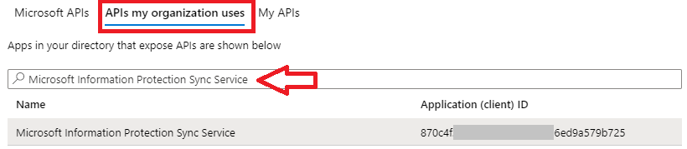
- Click on Microsoft Information Protection Sync Service.
- Click on Application Permissions.
- Below UnifiedPolicy, select UnifiedPolicy.Tenant.Read.
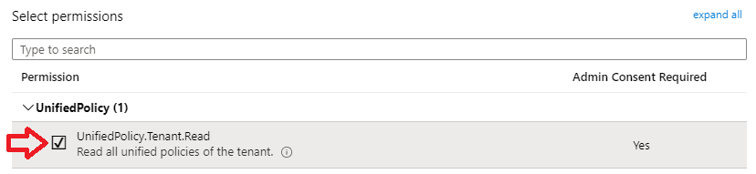
- Click Add permissions.
- On the AIP-DelegatedUser | API Permissions page, click Grant admin consent for <customer tenant name>.
- Click Yes.
- Verify the Status is set to Granted for…
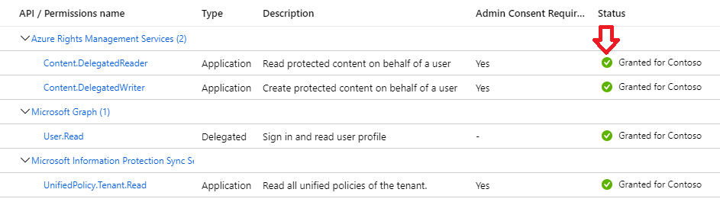
- Navigate to the Microsoft Entra ID by typing Entra ID in the search box for resources, services, and docs and then select Microsoft Entra ID.
- Below Overview, copy the string next to Tenant ID. Paste and save the value for later reference.
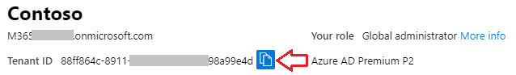
Tenant ID | ...........……………………………………………………………………………………………
Install Azure AD token on Scanner server
- Log on to the server that will run Purview Information Protection scanner with the previously created service account (SVC_Scanner).
- Open a Windows PowerShell session with the Run as an administrator option.
- Create a variable to store the credentials of the service account the Purview Information Protection scanner will use.
$pscreds = Get-Credential "CONTOSO\SVC_Scanner"
- Run the Set-Authentication cmdlet, with the OnBeHalfOf parameter, specifying as its value the variable that you just created. Also specify the app registration values, the tenant ID, and the name of the delegated user account in Azure AD.
Set-Authentication
-AppId "<Previously saved Application (client) ID >"
-AppSecret "<Previously saved Client Secret Value >"
-TenantId "<Previously saved TenantId>"
-DelegatedUser SVC_Scanner@contoso.com
-OnBehalfOf $pscreds
- Verify the result of the Set-Authentication cmdlet:
Acquired access token.
- Run services.msc and restart the Microsoft Purview Information Protection scanner service (requires the account to be local administrator).
Verify the Scanner node is recognized and assigned to the cluster
- Browse to the Microsoft Purview portal at https://purview.microsoft.com/ and log in with Tenant Admin credentials or a user account that is a member of your Data Security Envisioning Workshop team and has been assigned the appropriate permissions.
- In the navigation bar on the left side, click on Settings.
- On the Settings card, below Solution settings, click on Information protection.
- On the Information Protection settings page, click on Information Protection scanner.
- From the tabs on the Information protection settings page, select Nodes.
- Verify the scanner instance is listed and is assigned to the DataSecurityCheck-ScannerCluster.
- For the SCAN-01.contoso.com node, verify that Last seen is recently updated and there are no errors below Content scan job status.

Run on-premises Automated Discovery

Guidance
After completing the Purview Information Protection scanner installation and configuration in the previous sections, the next step is to run a first, manually initiated, discovery scan. The manual scan can be initiated from PowerShell or the Azure Information Protection Profile blade. This section will describe the steps to initiate the scan from the AIP portal.

Objective(s)
- Run the Purview Information Protection scanner against on-premises data repositories.

Background Reading
- Set-ScannerConfiguration
- Run a discovery cycle and view reports for the scanner

Instructions
Add test files to the on-premises file repository
- Create and copy test files that include the Sensitive Info Types the Purview Information Protection scanner has to identify to the data repositories configured in the Scanner Profile.
Start the Purview Information Protection scanner scan process
- Browse to the Microsoft Purview portal at https://purview.microsoft.com/ and log in with Tenant Admin credentials or a user account that is a member of your Data Security Envisioning Workshop team and has been assigned the appropriate permissions.
- In the navigation bar on the left side, click on Settings.
- On the Settings card, below Solution settings, click on Information protection.
- On the Information Protection settings page, click on Information Protection scanner.
- From the tabs on the Information protection settings page, select Content scan jobs.
- Select the DataSecurityCheck-ContentScanJob and click Scan now.

Note
Starting the scan job can be done from the Microsoft Purview portal or alternatively through PowerShell using the Start-Scan cmdlet.

- From the tabs on the Information Protection settings page, select Nodes.
- Verify the scanner is running.

Note
Verifying the scanner status can be done from the Microsoft Purview portal or alternatively through PowerShell using the Get-ScanStatus cmdlet.

Note
It can take up to five minutes before the scanner starts.

- Wait for the scanner to complete.
- From the tabs on the Information Protection settings page, select Content scan jobs.
- Verify scan results.

Note
Depending on the number of data repositories and files to scan, the initial scan job may take hours or even days to complete.

Check discovery logs and verify successful classification.
- Log on to the server that is running the Purview Information Protection scanner with the previously created service account (SVC_Scanner).
- Open %localappdata%\Microsoft\MSIP\Scanner\Reports in the File explorer.
- Open Summary_YYYY-MM-DD_UU_MM_SS.txt, inspect the file contents and search for errors or failures. Verify that (at least) the test files have been classified and that no documents are labeled or protected.
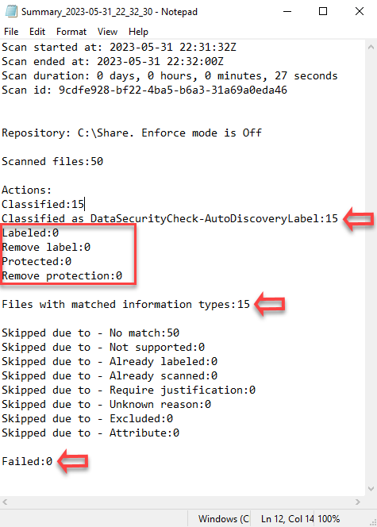
- Open DetailedReport_YYYY-MM-DD_UU_MM_SS.csv, inspect the file contents and search for errors or failures.
- Search for the file names of the test files you have previously added to scanned directory.
- Confirm successful classification.
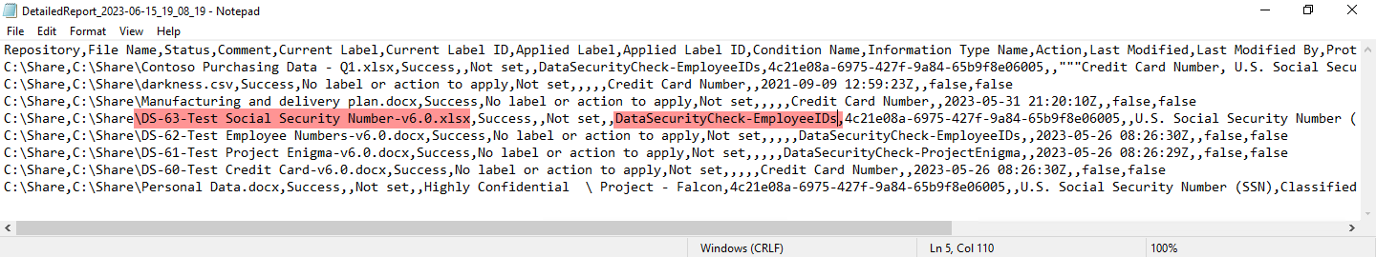

Note
The above example shows sample results of a scan process that identified files with social security numbers and Employee ID.

Configure for continuous auto discovery.

Note
After successfully completing the first manual scan cycle, it is recommended to configure the scanner for continuous scanning. This will enable the scanner to also report on data that is added during the two weeks of auto discovery.

- Browse to the Microsoft Purview portal at https://purview.microsoft.com/ and log in with Tenant Admin credentials or a user account that is a member of your Data Security Envisioning Workshop team and has been assigned the appropriate permissions.
- In the navigation bar on the left side, click on Settings.
- On the Settings card, below Solution settings, click on Information protection.
- On the Information Protection settings page, click on Information Protection scanner.
- From the tabs on the Information protection settings page, select Content scan jobs.
- On the Information Protection settings | Content scan jobs page, click the previously created content scan job DataSecurityCheck-ContentScanJob.
- Below Schedule, select Always.
- Click Save.

Next step
- Return to the <00-Master Delivery Guide> and continue the guidance provided in Step 3 - Setup and configuration.

Step 4 - Analyze the findings
In this step the partner will, together with the customer’s tenant / compliance administrator, analyze all logs, information, and reports generated by the different Data Security Check tools and services. This section will describe the additional steps required to prepare and analyze the results from the On-premises discovery.
It is recommended to do a two-step analysis of the logfiles, reports, and findings:
- Quick scan. By using the various dashboards and preview views you will be able to identify common patterns and/or trends that need further investigation and can serve as an example of privacy and regulatory risks. Look for “most impactful” events related to important people within the organization, high volumes of documents related to a specific business process, Personally Identifiable Information (PII), etc.
- Detailed analysis. Using exported log and report files for the various services will allow for further investigation of previously identified privacy and regulatory risks and events flagged during the quick scan. Aim at determining the impact and risk and consider possible solutions for mitigation. During this detailed analysis you are advised to leverage the insights of the customer team because they will know what and who to look for. To rule out “false positives” you are advised to do further investigation of all the events that will be included in the final close-out presentation at the end of the engagement.

Pre-requisites
Prior to starting the activities in this step, the following mandatory Data Security Check activities as described in <00-Master Delivery Guide> should be completed:
- Step 1 - Kick-off meeting
- Step 2 - Acquire and assign licenses
- Step 3 - Setup and configuration
- Step 4 - Analyze the findings

Prepare for analysis using Activity Explorer

Guidance
The results from the Purview Information Protection scanner activity can be viewed in the Microsoft 365 Activity explorer. Follow the steps outlined in this section to collect the results related to the On-premises discovery.
Note
The Purview Information Protection scanner is configured for user-initiated manual scanning. A manual scan generates a point in time report that is not updated if new files are added to the repositories or if existing files are changed. Within the context of the Data Security Check, the insights provided by the point-in-time reports will be considered representative and sufficient.

Objective
- Export the reports for the On-premises discovery from Activity Explorer to the local folder structure.
- Capture visualizations from Activity Explorer to get visibility into what content has been discovered, and where that content is located.

Background reading
For more information refer to:
- Get started with activity explorer

Instructions - Capture visualizations from Activity Explorer
- On the local workstation, if not already done, extend the previously created directory structure by creating the \DataSecurityCheck\PurviewScanner folder.
- Browse to the Microsoft Purview portal at https://purview.microsoft.com/ and log in with Tenant Admin credentials or a user account that is a member of your Data Security Check team and has been assigned the appropriate permissions.
- In the navigation bar on the left side, click on Solutions.
- In the Solutions navigator, click on Information Protection.
- On the Information Protection solution card, expand Explorers.
- Below Explorers, click on Activity explorer.
- On the Activity explorer page, click on  Add Filters.
- On the Add filters fly-out, select Application and click Add.
- On the Activity explorer page, click on Application and select Microsoft Purview Information Protection Scanner.
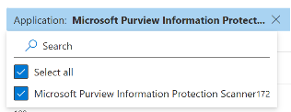
- Click on Apply.

Important
At time of writing this document, the Application filter in Activity Explorer does not correctly lists the entry for the Microsoft Purview Information Protection Scanner, and this currently is an unresolved service-side issue. The change stems from an internal schema update that consolidated telemetry from endpoint DLP, service DLP, and on-premises Information Protection Scanners into a unified signal pipeline within Microsoft Purview.
As a workaround, it is recommended to use the <User> and <Device> filters to create a dataset that only includes data discovered by the MIP Scanner. Set the User filter to the scanner’s service account (e.g., SVC_Scanner) and the Device filter to the scanner’s server name (e.g., SCAN-01) to isolate scanner-generated data.

- On the Activity explorer page, click on Date and match the start and end date to the auto discovery timeframe.
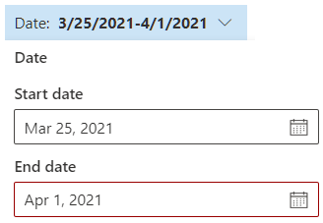
- Click on Apply.
- Take a screenshot of the data visualization and save the image as <DataSecurityCheck-OnPremisesDiscovery.jpg> to the \DataSecurityCheck\PurviewScanner directory for future use in the close-out presentation.
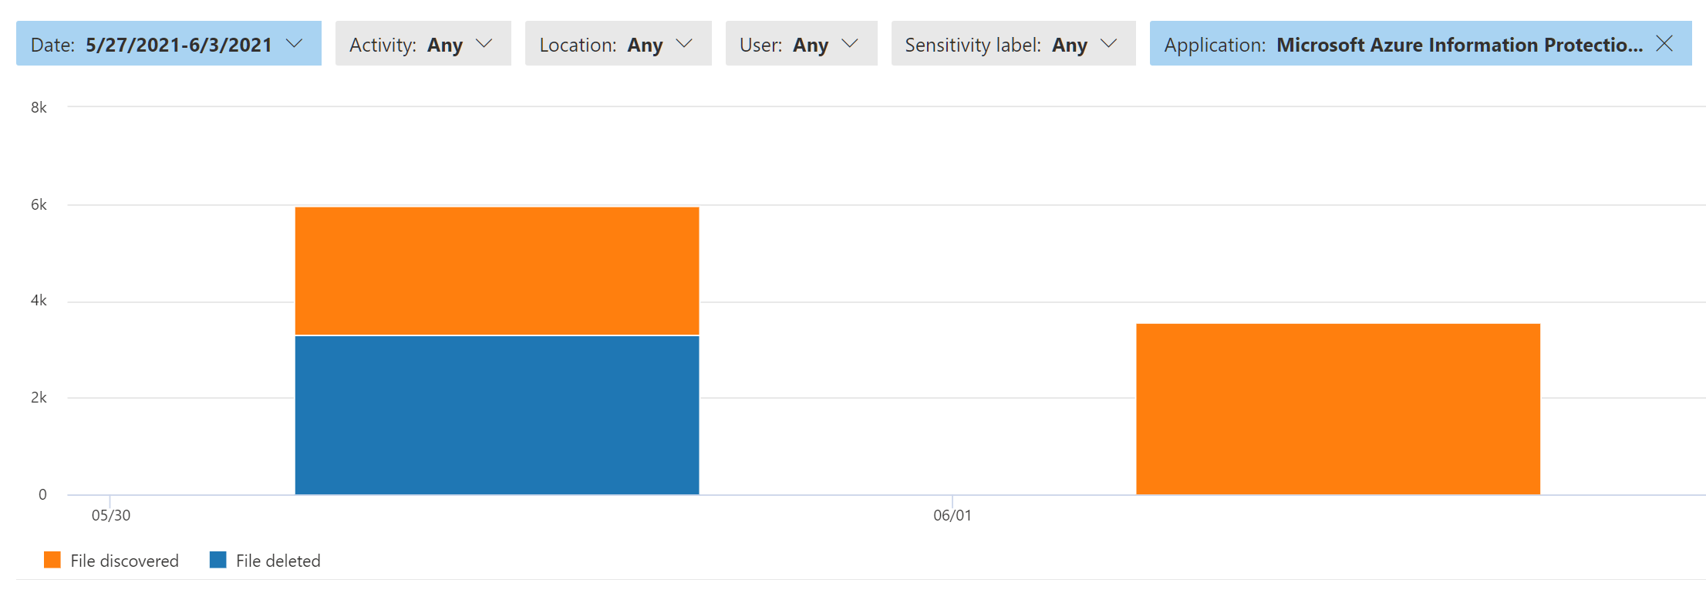
- On the Activity explorer page, click on  Customize columns.
- At a minimum select the following columns:
Activity, File, Location, Happened, Sensitive info type, Sensitive info type count
Leave all other columns de-selected.
- Click Apply.
- On the Activity explorer tab, click on Export.
- Copy the downloaded export file Activity explorer _ Microsoft Purview.csv to the \DataSecurityCheck\PurviewScanner folder on your local workstation.
Save scanner logfiles (Optional)

Note
Saving and analyzing scanner logfiles is an optional activity, all information can also be obtained from the Activity Explorer.

- Log on to the server that is running the Purview Information Protection scanner with the previously created service account (SVC_Scanner).
- Open %localappdata%\Microsoft\MSIP\Scanner\Reports in File Explorer.
- Copy the most recent Summary_YYYY-MM-DD_UU_MM_SS.txt file to \DataSecurityCheck\PurviewScanner folder on your local workstation.
- Copy the most recent DetailedReport_YYYY-MM-DD_UU_MM_SS.csv file to \DataSecurityCheck\PurviewScanner folder on your local workstation.

Note
DetailedReport_YYYY-MM-DD_UU_MM_SS.csv files are only created if new files are scanned by the Purview Information Protection scanner. If the scanner is configured for continuous scanning, the scanner will generate a Summary_YYYY-MM-DD_UU_MM_SS.txt file after every automatically initiated scan but this file does not provide information about previous scans. In this case you have to identify and copy a Reports zip file that includes a Summary and DetailedReport file.

Analyzing Activity Explorer results

Guidance
The screenshots and exported results of the On-premises discovery obtained from Activity Explorer are saved in the previously created directory \DataSecurityCheck\PurviewScanner.
The contents of the saved files should be analyzed and copied to the placeholder slide in the closeout-presentation <41-Close-out deck>.

Objective
- Analyze the reports for the On-premises discovery.

Instructions
Filename | Activity explorer _ Microsoft Purview.csv
Location | \DataSecurityCheck\PurviewScanner
Contains | Detailed information on the On-premises discovery:  - Repositories  - File names  - Identified artifacts

Usage #1 |  | Provide insight into sensitive information types discovered in on-premises data repositories.
Use in closeout deck? |  | YES
Instructions |  | - Import the export file into Excel following the instructions in the appendix of the <00-Master Delivery Guide>.  - Create a pivot table matching the definition depicted in the illustration below.  - When creating the close-out presentation, copy the pivot table to the appropriate slide in the deck.
Pivot table definition | 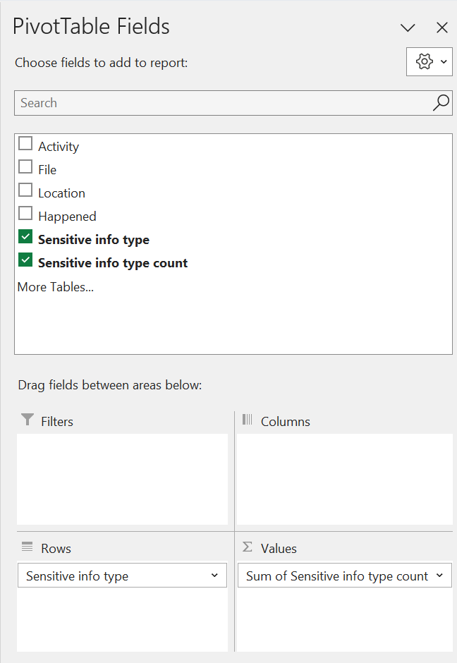 |  | Filters: Empty  Columns: Empty  Rows: Sensitive info type  Ʃ Values: Sum of sensitive info type count  Sort: Descending (Z to A) by Sum of sensitive info type count.
Sample illustration | Sensitive info types Sum of Sensitive info type count  Credit Card Number 456  DataSecurityCheck-EmployeeIDs 132  DataSecurityCheck-ProjectEnigma 96  U.S. Social Security Number (SSN) 380  Grand Total 1064
Usage #2 | Provide insight into sensitive information types per on-premises repository.
Use in closeout deck? | Yes
Instructions | - Import the export file into Excel following the instructions in the appendix of the <00-Master Delivery Guide>.  - Add an additional column to the worksheet named <Directory> that contains a formula to extract the directory name from the <file> column.  Note  Use the following formula as a starting point to extract the directory from the file name and update if needed.  =LEFT(B2,FIND("|",SUBSTITUTE(B2,"\","|",LEN(B2)-LEN(SUBSTITUTE(B2,"\",""))))-1)  The above formula assumes column B contains the filename and the extracted directory is in column G.  Input B2: C:\DATA_HR\File with Credit Cards.docx  Result G2: C:\DATA_HR  Input B3: \\Server-01\HR-Share\File with Credit Cards.docx  Result G3: \\Server-01\HR-Share  - Create a pivot table matching the definition depicted in the illustration below.  - When creating the close-out presentation, copy the pivot table to the appropriate slide in the deck.
Pivot table definition | 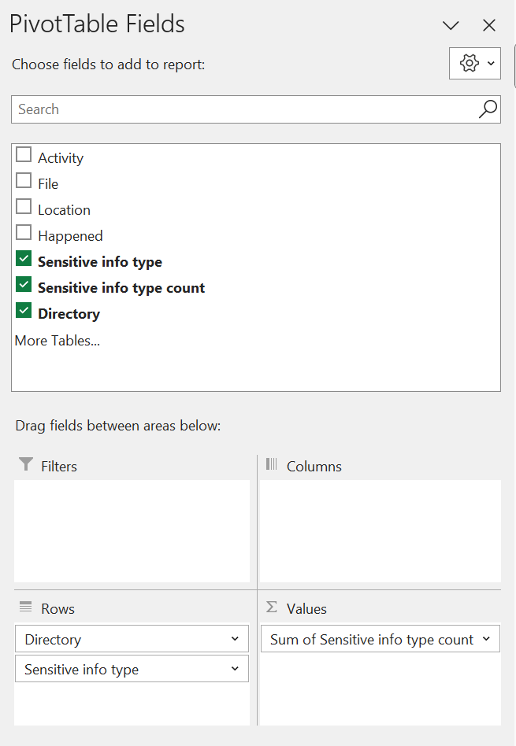 |  | Filters: Empty  Columns: Empty  Rows: Directory, Sensitive info type  Ʃ Values: Sum of sensitive info type count  Sort: Descending (Z to A) by Sum of sensitive info type count.
Sample illustration | Data Repositories Sum of Sensitive info type count  C:\DATA_FINANCE 400  Credit Card Number 216  DataSecurityCheck-EmployeeIDs 44  U.S. Social Security Number (SSN) 140  C:\DATA_HR 664  Credit Card Number 240  DataSecurityCheck-EmployeeIDs 88  DataSecurityCheck-ProjectEnigma 96  U.S. Social Security Number (SSN) 240  Grand Total 1064

Next step
- Return to the <00-Master Delivery Guide> and continue the guidance provided in Step 4 - Analyze the findings.

Analyzing discovery findings scanner log files (Optional)

Guidance
The results of the On-premises discovery are exported into two files:
- Summary_YYYY-MM-DD_UU_MM_SS.txt
- DetailedReport_YYYY-MM-DD_UU_MM_SS.csv
The contents of these two files are used to get summary information regarding the On-premises discovery activity. Copy the information to the placeholder slide in the closeout-presentation <41-Close-out deck>.

Note
The preferred way to analyze the scan results is to use the Activity Explorer. Analyzing the scanner logfiles is an optional activity that can add additional insights.

Objective
- Analyze the reports for the On-premises discovery.

Instructions
Filename | Summary_YYYY-MM-DD_UU_MM_SS.txt
Location | \DataSecurityCheck\PurviewScanner
Contains | High-level information on the On-premises discovery.  - Total number of files scanned  - Total number of files that contain the pre-defined search artifacts  - Names of the repositories included in the scan  - Total of failed scan actions
Usage | Provide high-level overview of findings.
Use in closeout deck? | Optional
Instructions | - Open the file in Notepad.  - Copy the relevant information to the placeholder slide in the close-out presentation.
Sample illustration | 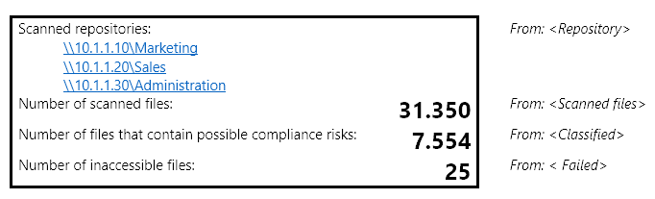

Step 6 - Decommission

Guidance
The final activity for the On-premises discovery activity is to decommission the services and tools used for this activity.
Important
Do not perform the decommissioning steps, if the customer chooses to do so, until after the Proof of Execution (POE) has been filled out. The POE requires that evidence of the configuration is captured and will not be able to be completed if all of the policies are removed.

Objective(s)
The objectives for this activity are:
- Decommission the services that were installed to support the On-premises discovery.

Deliverable(s)
For this activity, the following deliverables have been defined:
- All tools and services used during the On-premises discovery are decommissioned.
- All custom configuration artifacts are removed from the customer’s tenant.

Instructions – delete the Label policy
- Browse to the Microsoft Purview portal at https://purview.microsoft.com/ and log in with Tenant Admin credentials or a user account that is a member of your Data Security Check team and has been assigned the appropriate permissions.
- In the navigation bar on the left side, click on Solutions.
- In the Solutions navigator, click on Information Protection.
- On the Information Protection solution card, expand Policies.
- Below Policies, click on Label Publishing policies.
- Click on DataSecurityCheck-AutoDiscoveryPolicy.
- On the DataSecurityCheck-AutoDiscoveryPolicy details fly-out, click Delete policy.
- On the Delete policy pop-up, click Confirm to confirm deletion.

Instructions – Delete the label
- On the Information Protection solution card, click on Sensitivity labels.
- On the Sensitivity labels page, select the DataSecurityCheck-AutoDiscoveryLabel.
- Click  Delete label .
- On the Warning pop-up, click Yes to confirm deletion.

Instructions – Delete the Information Protection settings Cluster configuration
- In the navigation bar on the left side, click on Settings.
- On the Settings card, below Solution settings, click on Information protection.
- On the Information Protection settings page, click on Information protection scanner.
- On the Information Protection settings page, click Clusters to select the Clusters tab.
- Select the DataSecurityCheck-ScannerCluster.
- Click on Delete cluster.
- On the Warning pop-up, click on Yes.

Instructions – Delete the Information Protection settings Content scan job configuration
- On the Information Protection settings page, click Content scan jobs to select the Content scan jobs tab.
- Select the DataSecurityCheck-ContentScanJob.
- Click on  Delete.
- On the Warning pop-up, click on Yes.

Instructions – Delete the Information Protection settings Node configuration
- On the Information Protection settings page, click Nodes to select the Nodes tab.
- Select the scanner node you created in 2.3.8-Install the Purview Information Protection scanner.
- Click  Delete node.
- On the Warning popup, click on Yes.

Instructions – Delete the Information Protection settings App registration
- Browse to the Microsoft Azure portal at https://portal.azure.com and log in with Tenant Admin credentials or a user account that has been assigned the appropriate permissions.
- Navigate to Entra ID by typing Entra in the search box for resources, services, and docs and then select Microsoft Entra ID.
- On the left-side menu, below Manage click App registrations.
- Click on All applications to switch to the All applications tab.
- Click on the App registration (AIP-DelegatedUser ) created in paragraph 2.3.9-Acquire a Microsoft Entra token for the scanner.
- On the AIP-DelegatedUser details page for the app registration, click Delete.
- On the Delete app regsutration fly-out, click the check box I understand the implications…
- Click Delete.

Instructions – Deprecate server(s) and remove service account(s)
- Deprecate the Windows server running AIP Server.
- Delete the Purview Information Protection scanner service account (SVC_Scanner) from Active Directory.

Next step
- Return to the <00-Master Delivery Guide> and continue the guidance provided in Step 6 - Decommission.

